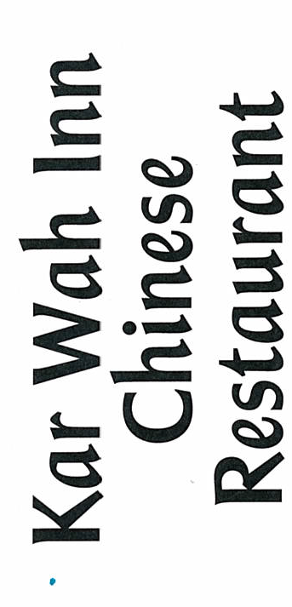

~ Roast Dinner Menu ~

2 Course meal
$30.00 per person
Prawn cocktail OR Mixed Entrée

Roast Chicken OR Roast Beef OR Roast Pork
Served with Pumpkin, Potatoes, Peas, Cauliflower, Carrots & Gravy

3 Course meal
$35.00 per person
Prawn Cocktail OR Mixed Entree OR Pumpkin Soup

Roast Chicken OR Roast Beef OR Roast Pork
Served with Pumpkin, Potatoes, Peas, Cauliflower, Carrots & Gravy

Pavlova OR Cheese Cake OR Mud Cake
Served with Whipped Cream or Ice Cream

